Week 1 - Week commencing 31/1/2022

**Week Outline**

In-person meeting to visit the camera, take simple measurements and rediscuss the aims and objectives of the project and how the project will move forward. This week is mostly a refresher into the project as this semester will focus more on analyzing experimental detector data than understanding any additional theory. The tasks for this week is to understand what the aims and objectives of the project moving forward and read in I and Q values, and attempt to convert to dF0 using the “Magic Formula”. In addition, some photos and simple measurements were taken for future use.

**Complete Python Code Attached at the End of Diary**

**Tasks Outline**

* Obtain and read-in detector data
* Convert I & Q values to dF0 using “Magic Formula”
* Plot dF0 vs Time

**Simple Measurements**

**Photos of Camera Setup**

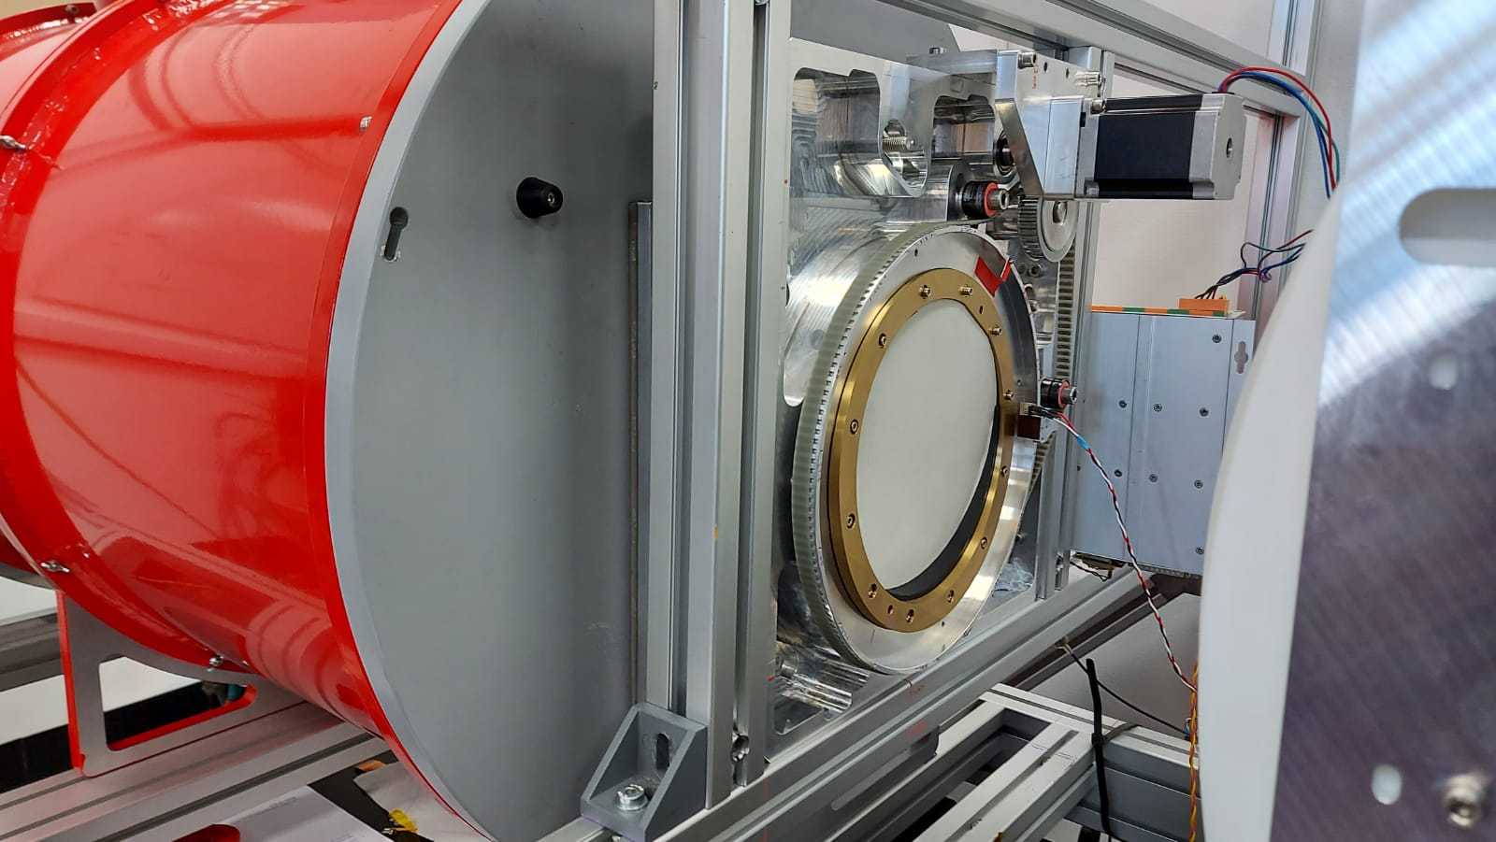

Camera. The red drum contains the detector inside held at ~300mK.

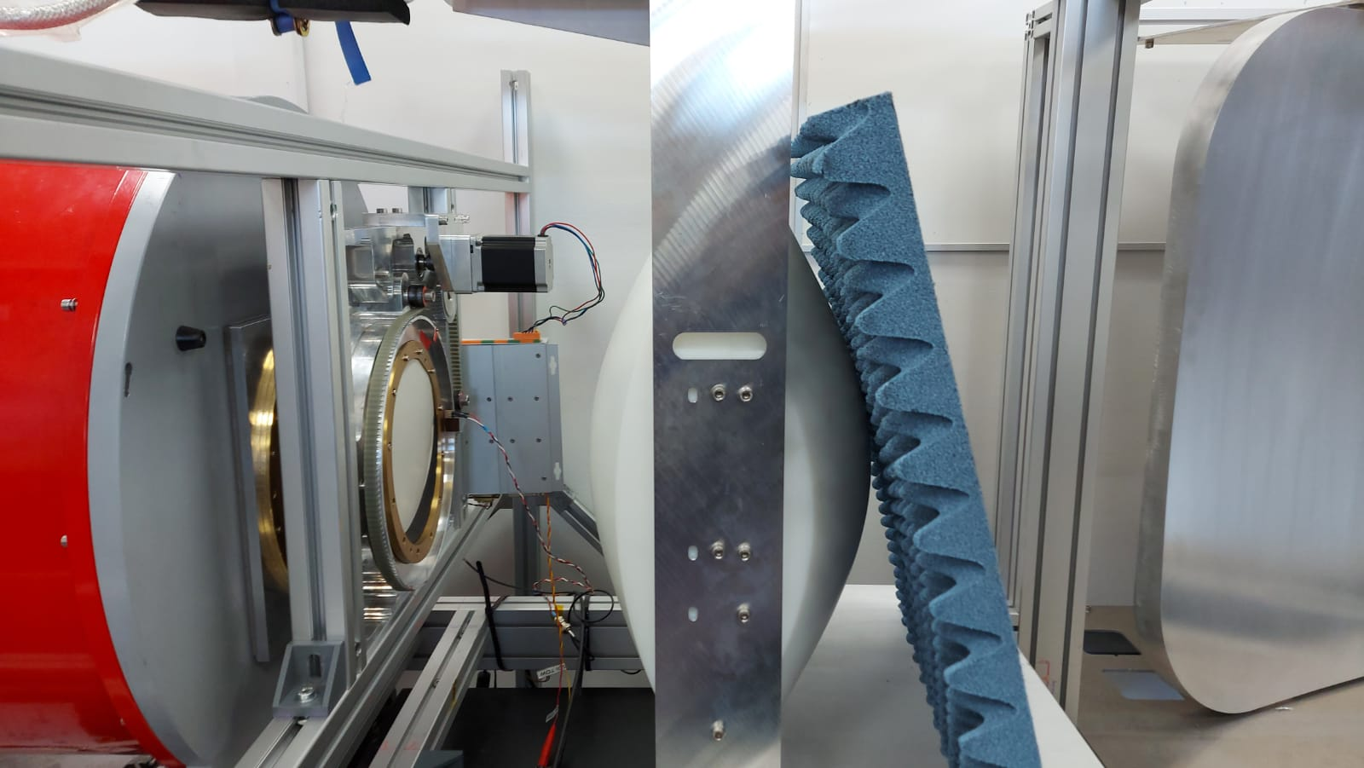

Detector with foam screen.

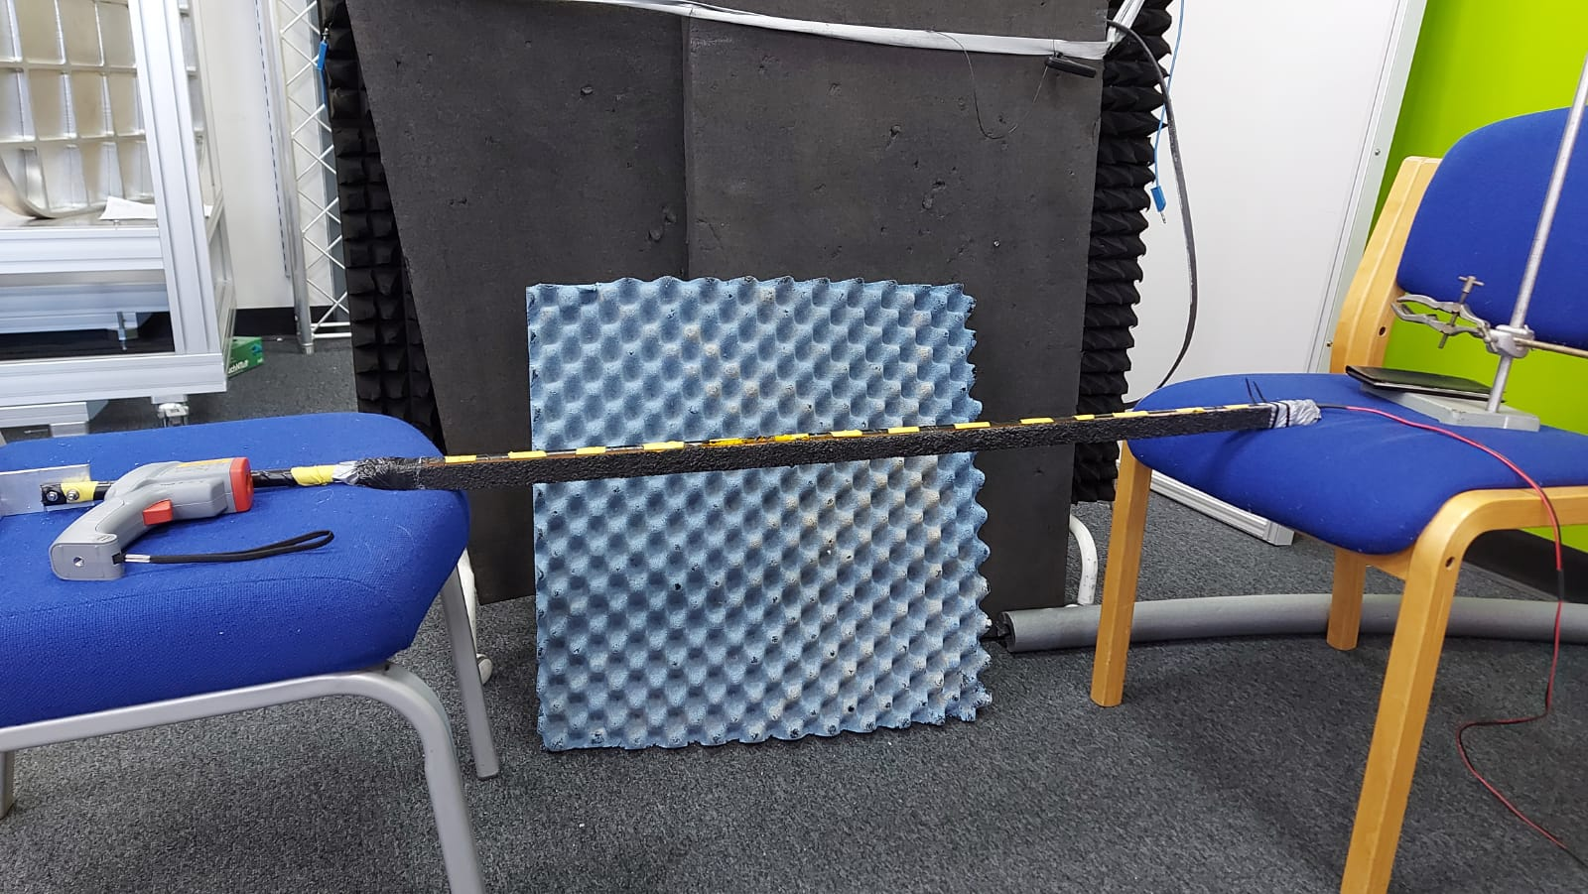

Setup of hot bar, heated electrically.

**Measured Data**

For the detector data, there are 2 sets of detector data that will be used throughout the project for analysis:

1. Measurement of a blank screen. 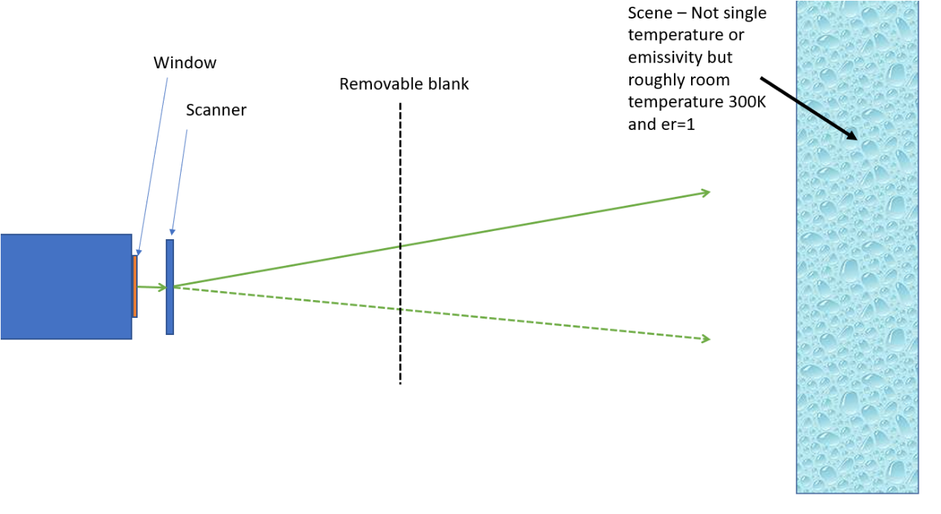

This data allows us to measure the background for noise analysis.

1. Measurement with a hot bar

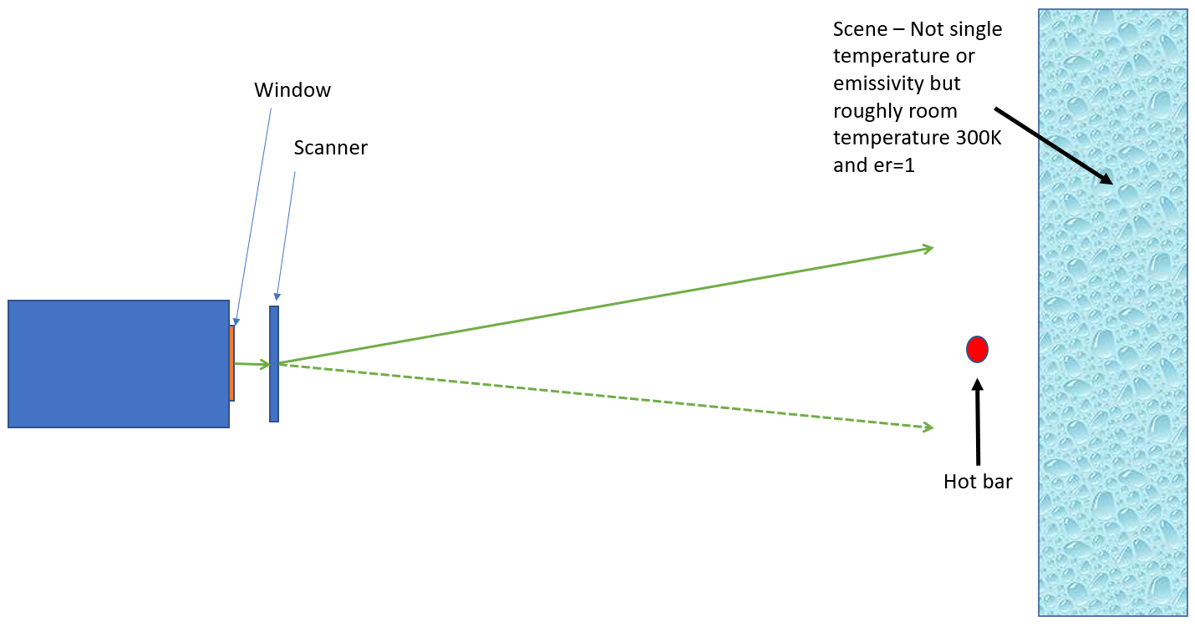

This data allows us to characterize the response of the detector, with known temperature of the hotbar.